Cloud Day-1
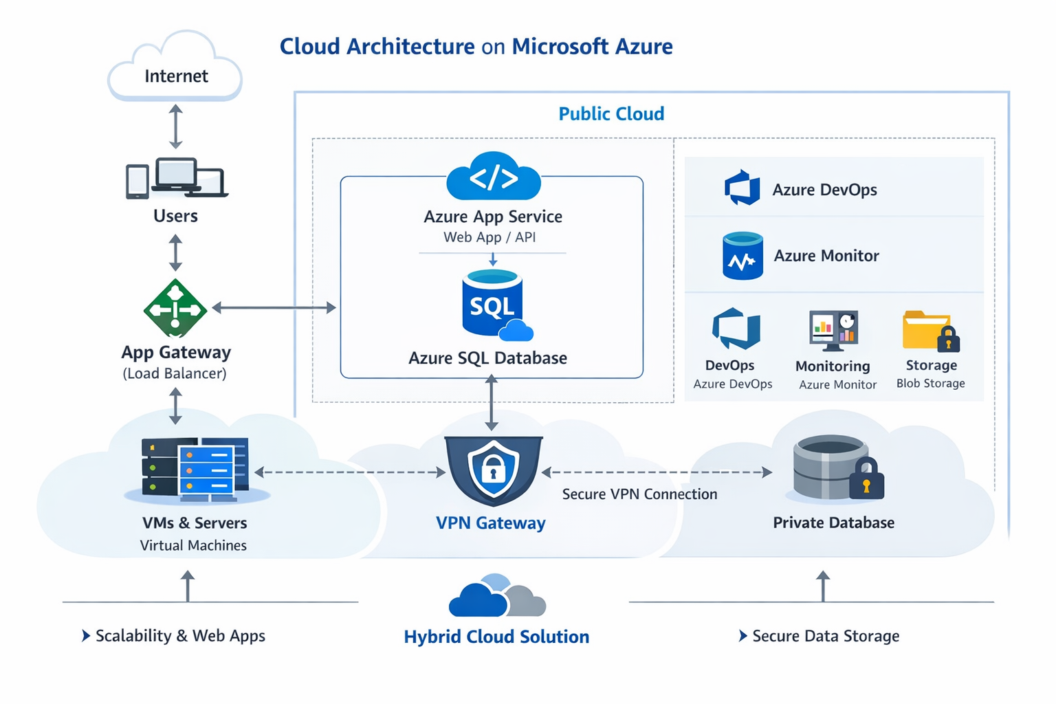

1. Overview of Cloud Computing

What is Cloud Computing?
Cloud computing means delivering computing services over the internet instead of using local servers or personal computers.
These services include:
- Servers
- Storage
- Databases
- Networking
- Software
- Analytics
Example:
Instead of storing files on your PC → you use Google Drive or Microsoft OneDrive

Key Characteristics
- On-demand self-service → Create resources anytime
- Broad network access → Accessible from anywhere
- Resource pooling → Shared resources across users
- Scalability → Scale up/down easily
- Pay-as-you-go → Only pay for what you use

Types of Cloud Services
- IaaS (Infrastructure as a Service)
  - Virtual machines, storage
  - Example: Azure VM
- PaaS (Platform as a Service)
  - Platform to build apps
  - Example: Azure App Service
- SaaS (Software as a Service)
  - Ready-to-use applications
  - Example: Microsoft 365

2. Benefits of Cloud Computing

1. Cost Effective
- No need to buy expensive hardware

2. Scalability
- Increase/decrease resources instantly

3. High Availability
- Data centers ensure uptime

4. Backup & Disaster Recovery
- Automatic backups

5. Security
- Advanced security features (encryption, firewall)

6. Global Reach
- Deploy apps worldwide

3. CapEx vs OpEx

CapEx (Capital Expenditure)
- Upfront investment
- Buying physical servers, infrastructure
Example:
- Purchasing servers for a company
Problems:
- High cost
- Maintenance required
- Hard to scale

OpEx (Operational Expenditure)
- Pay-as-you-go model
- Pay only for what you use
Example:
- Paying for Azure VM usage monthly

Key Difference Table
Feature | CapEx | OpEx
Cost Type | Upfront | Pay-as-you-go
Flexibility | Low | High
Risk | High | Low
Maintenance | Your responsibility | Cloud provider handles
Cloud computing mainly uses OpEx model

4. Overview of Public Cloud

Definition
Cloud services provided over the internet by third-party providers.
Examples:
- Microsoft Azure
- Amazon Web Services
- Google Cloud

Characteristics
- No hardware management
- Shared infrastructure
- Highly scalable
- Pay-as-you-go

Use Cases
- Web applications
- Startups
- Testing & development

5. Overview of Private Cloud

Definition
Cloud environment dedicated to a single organization
Can be:
- On-premises
- Hosted by third-party

Characteristics
- More control
- Higher security
- Custom configuration

Use Cases
- Banking systems
- Government organizations
- Healthcare systems

Limitation
- Expensive
- Requires maintenance

6. Overview of Hybrid Cloud

Definition
Combination of:
Public Cloud + Private Cloud

How it Works
- Sensitive data → Private Cloud
- General workloads → Public Cloud

Example Scenario
- Bank stores customer data in private cloud
- Uses public cloud for web apps

Benefits
- Flexibility
- Cost optimization
- Security + scalability balance

Quick Comparison
Feature | Public Cloud | Private Cloud | Hybrid Cloud
Ownership | Third-party | Single organization | Both
Security | Medium | High | High
Cost | Low | High | Medium
Scalability | High | Limited | High

Real-World Example (Azure)
Imagine you're building a Web API project (.NET 9):
- Hosting API → Azure App Service (Public Cloud)
- Database → Azure SQL
- Sensitive data → Private server
- Combined → Hybrid Cloud

Interview Tips (Very Important)
Common Questions:
- Difference between Public, Private, Hybrid Cloud
- What is CapEx vs OpEx?
- Benefits of cloud computing
- Types of cloud services (IaaS, PaaS, SaaS)
- Why companies prefer cloud over on-premises

What is CapEx and OpEx in Cloud?

1. CapEx (Capital Expenditure)

Definition
CapEx means spending money upfront to buy physical infrastructure.

In IT / Traditional Setup:
You purchase:
- Servers
- Networking devices
- Storage hardware
- Data center space

Example (Without Cloud)
A company buys:
- 10 servers for ₹10 lakh
- Sets up data center
This is CapEx because:
- One-time investment
- Long-term asset

Problems with CapEx
- High initial cost
- Risk if demand decreases
- Maintenance cost
- Scaling is difficult

2. OpEx (Operational Expenditure)

Definition
OpEx means paying for services based on usage (pay-as-you-go).

In Cloud (Azure, AWS)
Instead of buying servers:
- You rent resources
Example using Microsoft Azure:
- Create Virtual Machine
- Pay hourly/monthly

Example (With Cloud)
- Use VM for 10 hours → pay only for 10 hours
- Stop VM → no cost
This is OpEx

How It Works in Cloud (Important)

Behind the Scenes
Cloud providers like Microsoft Azure already:
- Own data centers
- Maintain hardware
- Handle electricity, cooling, networking

Your Role
You:
- Create resource (VM, App Service, Database)
- Use it
- Get billed based on:
  - Time (hours)
  - Storage used
  - Requests

Example Flow
Step 1: Create Azure VM
Step 2: Use for 5 hours
Step 3: Stop/Delete VM
Step 4: Pay only for 5 hours usage
No upfront cost = OpEx model

CapEx vs OpEx (Side-by-Side)
Feature | CapEx | OpEx
Cost Type | Upfront | Pay-as-you-go
Ownership | You own hardware | Cloud provider owns
Flexibility | Low | High
Risk | High | Low
Maintenance | Your responsibility | Provider handles
Scaling | Hard | Easy

Real-World Scenario (VERY IMPORTANT)

Traditional (CapEx)
A startup:
- Buys servers for ₹20 lakh
- Traffic is low → waste of money

Cloud (OpEx)
Same startup uses:
- Azure App Service
- Azure SQL
Pays only ₹5,000/month initially
Scales when users increase

Why Cloud Uses OpEx
Cloud providers like:
- Amazon Web Services
- Google Cloud
Follow OpEx because:
- Customers don’t want heavy investment
- Flexible scaling needed
- Faster business start

Interview Trick (Remember This Line)
“CapEx = Buy and Own, OpEx = Rent and Use”

When to Use What?

Use CapEx when:
- Long-term stable workload
- Large enterprise infrastructure

Use OpEx when:
- Startup / new project
- Uncertain traffic
- Need scalability

Final Understanding
Cloud = Mostly OpEx Model
Traditional IT = CapEx Model

